Name: ___________________________ Date:_______________

**Start**

RIDDLER’S MAZE #3

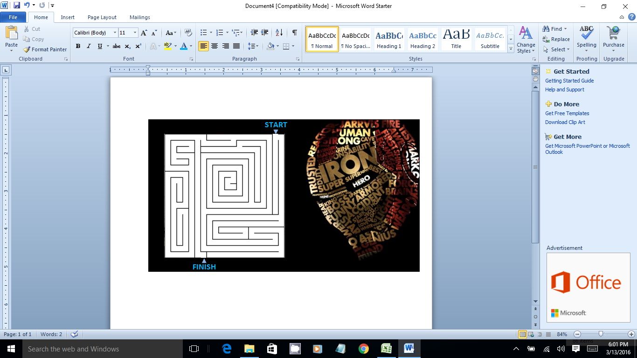

**Finish**